Data Analytics (DA) - Module -1 - Excel
Excel Assignment 1 – Data Exploration

Basic Data Exploration:
1. Sum, Count, and Average:
SUM - Adds all product prices together to calculate the total price
The total price of all products in the dataset is $10,100
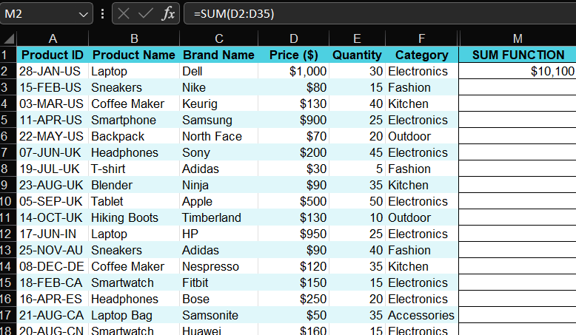
COUNT – Counts the total number of products in the dataset
There are 34 Products in the dataset
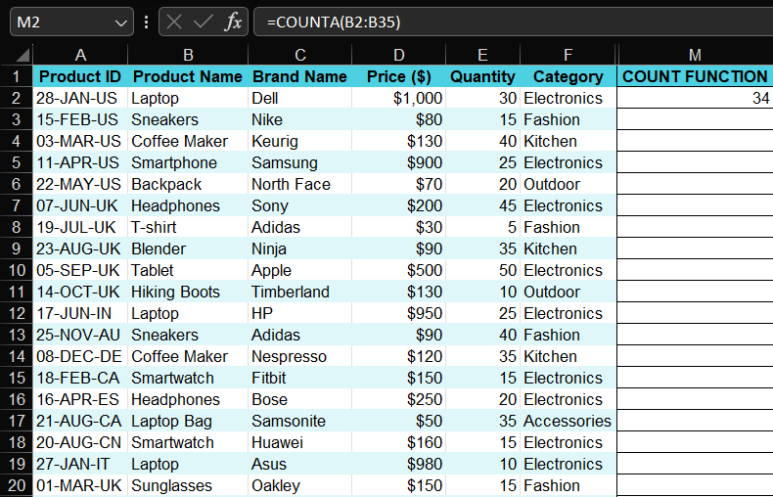

AVERAGE – Calculates the mean price of all products
The Average price of the products is $297.06
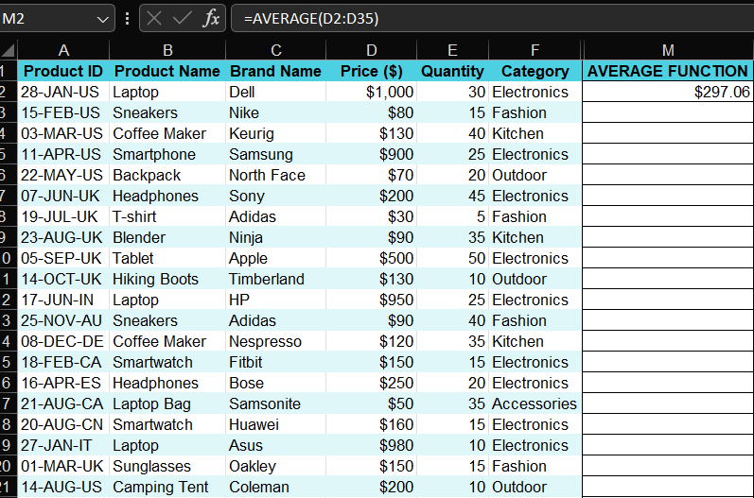
2. Minimum and Maximum Values:
MINIMUM - Finds the lowest product price in the dataset
the minimum price among all products is $30
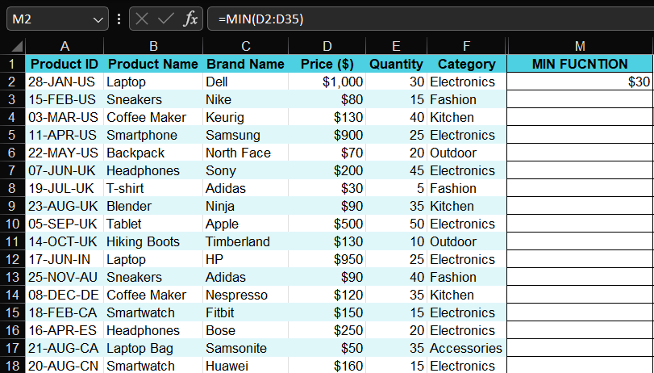

MAXIMUM – Finds the highest product price in the dataset
the maximum price among all products is $1000
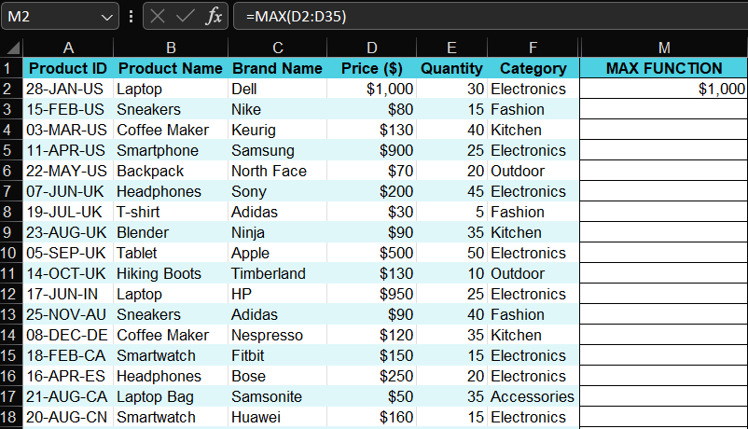
3. Logical Function – IF:
IF: Classifies products as High Price or Standard Price based on the price condition
If Price ≥ $500 → High Price
If Price < $500 → Standard Price
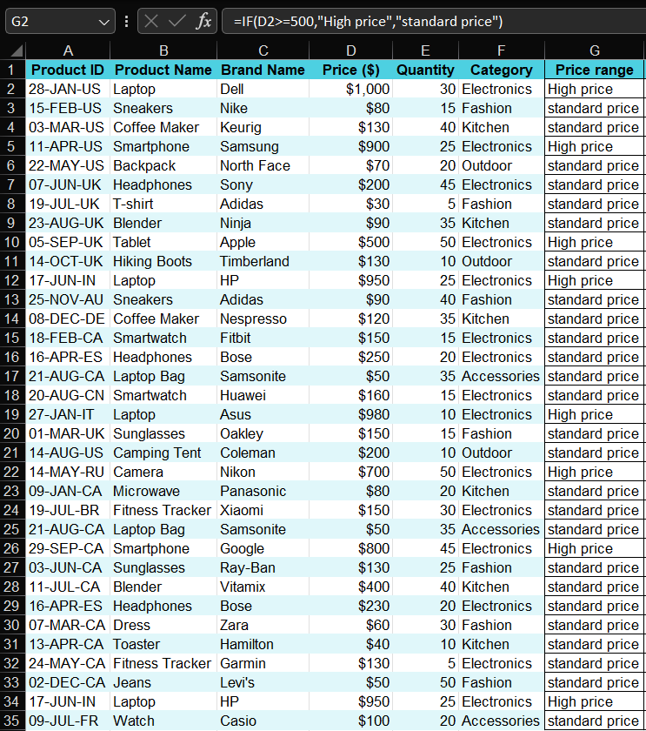

4. Conditional Functions – SUMIF and COUNTIF:
SUMIF function - Adds prices only for products belonging to the Electronics category
The total price of products in the Electronics category is $8,050
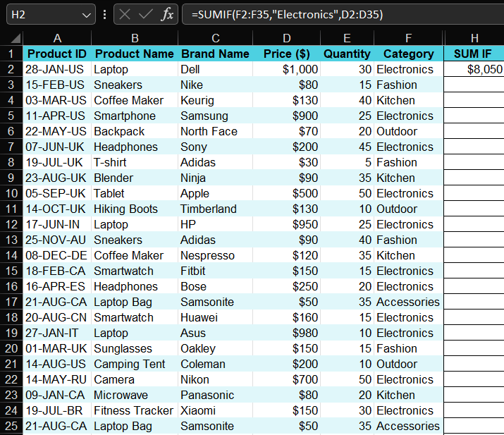
COUNTIF function - Counts products whose price is less than $100 based on a condition
the number of products with a price less than $100 is 11
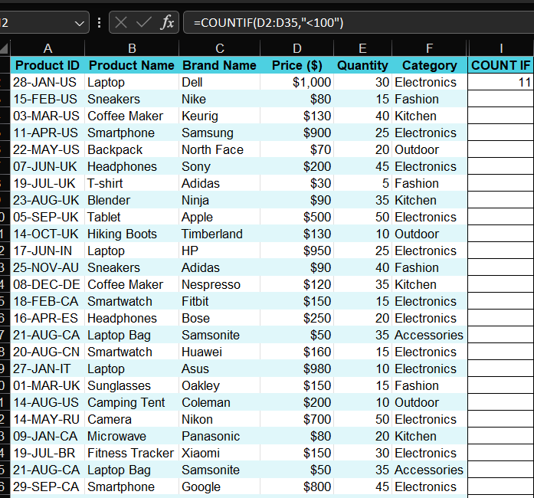
5. Text Formatting – LEFT, RIGHT, MID:
LEFT function - Extracts the first two characters (Day) from the Product ID
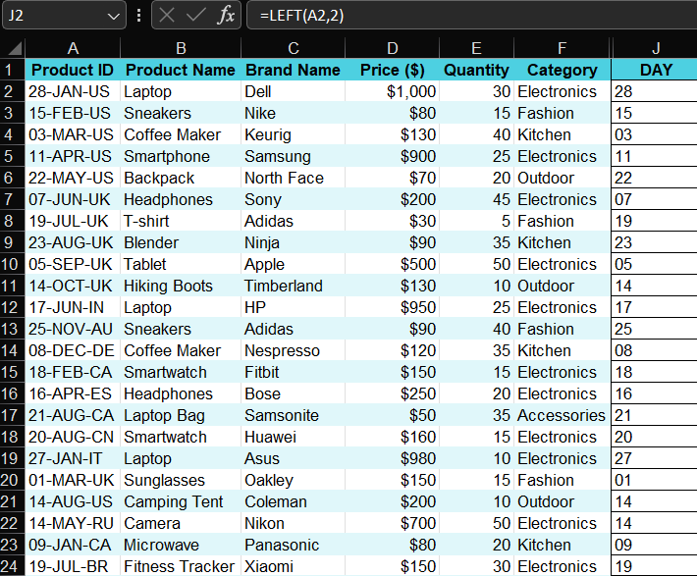

RIGHT function – Extracts the last two characters (Country Code) from the Product ID.

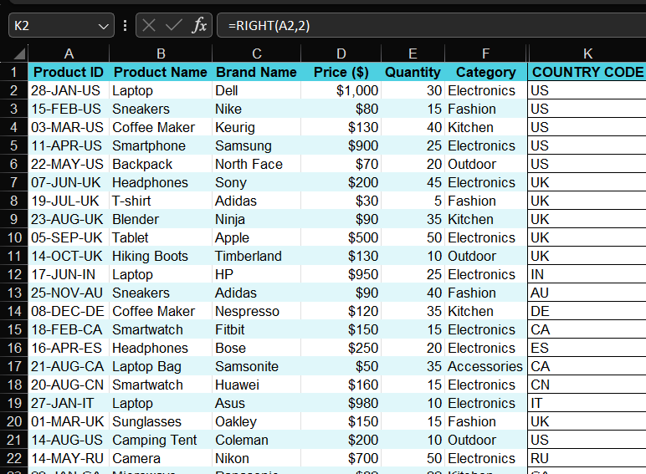

MID function – Extracts the middle characters (Month) from the Product ID
